Committed to delivering a safe environment
www.safegolf.org
for golf

Is something worrying you?
Do you need someone to talk to?
Speak to your club welfare officer
n.riches6@icloud.com
WELFARE OFFICER MOBILE NUMBER: 07460191229
NEIL RICHES

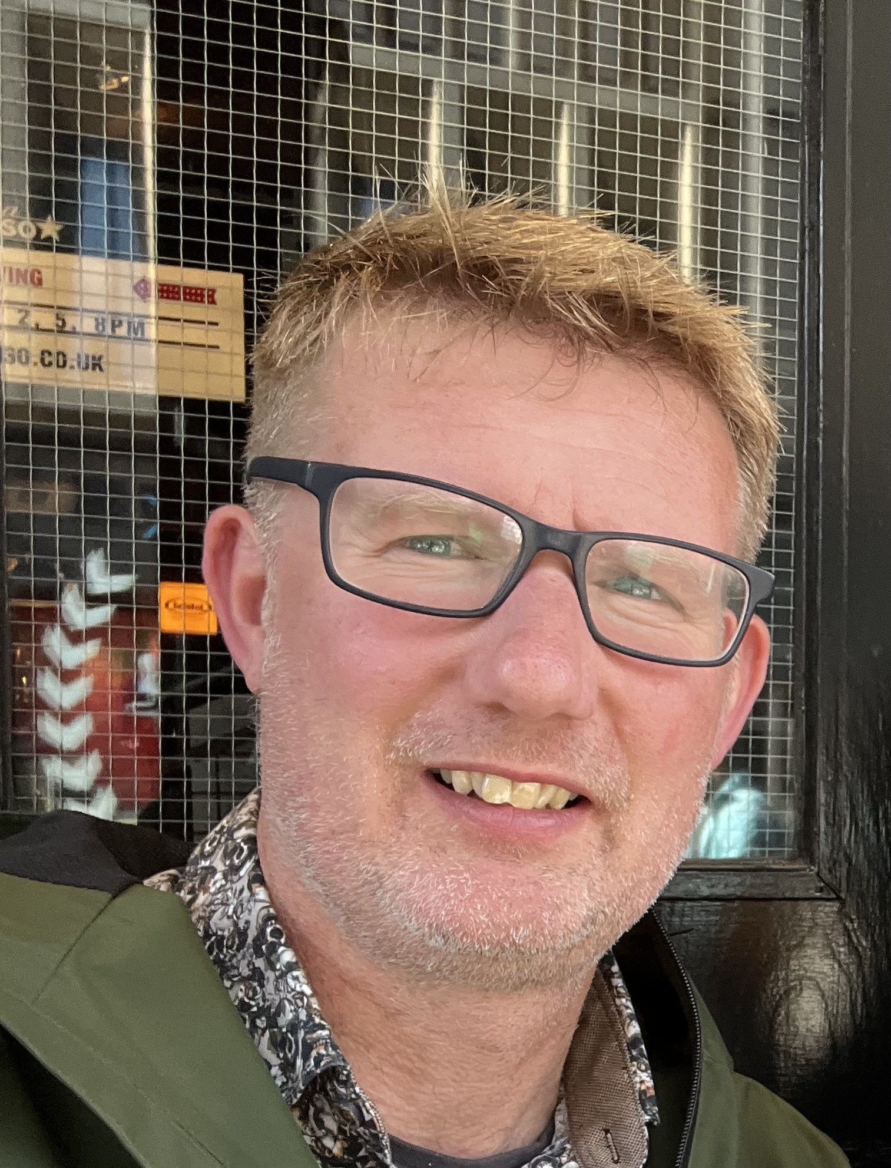

PHOTO

Clicktoadd photo
Alternatively, you can speak to someone at
ChildLine 0800 1111
ABOUT ME

I have been playing golf for about 18 years and been a member at Lansil for most of that time. Outside of golf I am happily married with two boys aged 19 and 17. I am currently working as a deputy headteacher of a local primary school. I am the Designated Safeguarding Lead for the school, therefore safeguarding is a large part of my role.
If you have any safeguarding concerns or worries don’t hesitate to get in touch.
NSPCC 0808 800 5000
England Golf 01526 351851
Club
WELFARE
officer

